**HOTEL EMRALD**

**HOME PAGE**

Presentation Layer:

* In the navbar of Home page there will be a login it consists of admin section and receptionist section.
* In the same navbar one contact also there and that comprises of important contacts of the Hotel employees
* Right below the navbar there will be a slideshow
* The body part of main page, will display some suave pictures regarding Hotel views

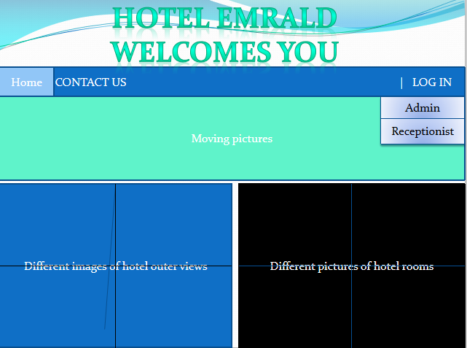

**ADMIN LOGIN:**

Presentation Layer:

For admin login: we have to click the admin in the navbar login dropdown it will redirect to the login page of admin, there we have to put the correct login credentials of admin.

* It will have one “Login” button at bottom and two text boxes-
  + Username
  + Password

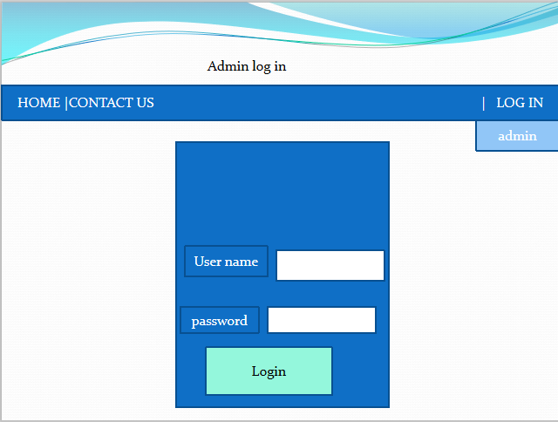

* After the successful login the admin main page will come up and that page consists of some options like Employee info ,add employee, Rooms info , Add room(elaborating further) and Logout in top right corner.

Service Layer:

When we click on admin login button the service layer function gets called named as login ()-

* Input argument- username and password
* Return status as 1 on successful login-it will redirect to post login page
* Return status 0 on login failure- we will show “Login failed”

Dao Layer:

findById() function gets called and password will be checked with database password-

* Input argument- username
* Return- Admin object

*Employee info*

Presentation Layer:

It will consist of all employees who are presently working in Hotel.

* A table of employees will come up containing several columns and every record will have buttons like update(for further updation in future).
* Table will contain columns named as-
  + EmpId
  + Govt_id
  + NAME
  + Permanent_address
  + Temporary_address
  + Gender
  + DOB
  + Local_reference
  + Phone_no

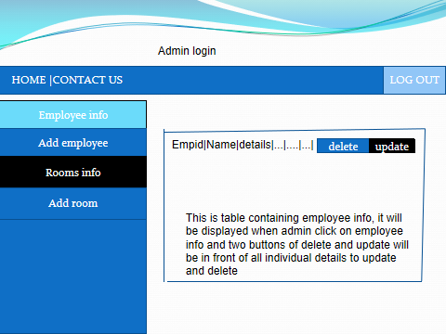

Service Layer:

When we click on EmployeeInfo button the service layer function gets called named as employeeInfo() -

* Input argument- nothing
* Return status as 1 and it will contain a list of employees-it will redirect to Employee Information page
* Return status 0 on no record- we will show “No record found”

Dao Layer:

findEmpList() function gets called -

* Input argument- nothing
* Return- ArrayList of Employee object

*Add Employee*

Presentation Layer:

It is basically for the hiring new employee purpose, after clicking -

* It will redirect to the form and there we will fill the whole form, regarding the personal information of that particular employee.
* Form will contain text boxes named as-
  + EmpId
  + Govt_id
  + NAME
  + Permanent_address
  + Temporary_address
  + Gender
  + DOB
  + Local_reference
  + Phone_no
  + Status (working or not working)
* In the bottom there will be an Add button it will add the employee to the database.

Service Layer:

When we click on Add button the service layer function gets called named as addEmployee() -

* Input argument- Employee Object
* Return status as 1 if it saves the data successfully into the database-it will redirect to Admin Post Login page
* Return status 0 on adding failure- we will show “not added”

Dao Layer:

save() function gets called -

* Input argument- Employee object
* Return- Employee object

*Room info:*

Presentation Layer:

In this section there will be the statuses of Rooms basically it’s for checking purpose weather it is occupied or not.

* A table of Rooms will come up containing several columns.
* Table will contain columns named as-
  + Room No.
  + Room Type
  + Booking Status
  + Cleaning Status

Service Layer:

When we click on Room Info button the service layer function gets called named as roomInfo() -

* Input argument- nothing
* Return status as 1 and it will contain a list of Room-it will redirect to Room Information page
* Return status 0 on no record- we will show “No record found”

Dao Layer:

findRoomList() function gets called -

* Input argument- nothing
* Return- ArrayList of Room object

*Add room:*

Presentation Layer:

Here we will adding new rooms in respect of type.

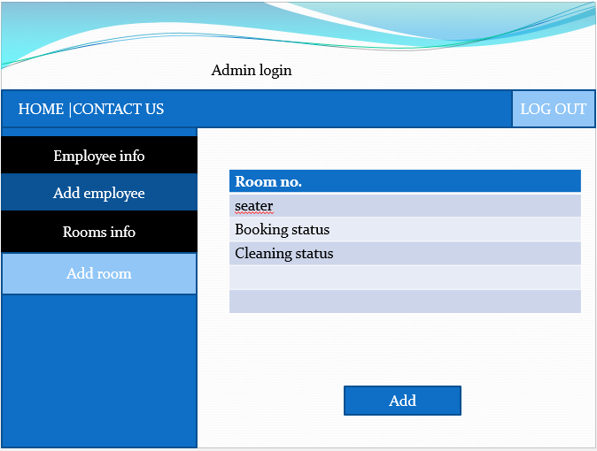

* It will redirect to the form and there we will fill the whole form, regarding the details of a room.
* Form will contain text boxes named as-
  + Room No.
  + Room Type
  + Booking Status
  + Cleaning Status
* In the bottom there will be an Add Room button it will add the Room to the database.

Service Layer:

When we click on Add Room button the service layer function gets called named as addRoom() -

* Input argument- Room Object
* Return status as 1 if it saves the data successfully into the database-it will redirect to Admin Post Login page
* Return status 0 on adding failure- we will show “not added”

Dao Layer:

save() function gets called -

* Input argument- Room object
* Return- Room object

**RECEPTION SECTION**

In the main Home page we have login section (admin part explained above) we have reception part Here the receptionist will book the rooms according to the preference of the guests.

Presentation Layer:

For Receptionist login: we have to click the Reception in the navbar login dropdown it will redirect to the login page of Receptionist, there we have to put the correct login credentials of Receptionist.

* It will have one “Login” button at bottom and two text boxes-
  + Username
  + Password
* After the successful login the Receptionist main page will come up and that page consists of some options like *RoomInfo* , *View Customer details* , and Logout in top right corner.

Service Layer:

When we click on Receptionist login button the service layer function gets called named as loginRec ()-

* Input argument- username and password
* Return status as 1 on successful login-it will redirect to post login page
* Return status 0 on login failure- we will show “Login failed”

Dao Layer:

findById() function gets called and password will be matched with database password-

* Input argument- username
* Return- Receptionist object

*RoomInfo:*

Presentation Layer:

* Firstly the receptionist will check the availability of the rooms, and according to the convenience, he or she will suggest.
* In the section of room info there will be a table of Rooms containing several columns and every row will have buttons like Update Status, Vacant, Book .
* Table will contain columns named as-
  + Room No
  + Room Type
  + Booking Status
  + Cleaning Status
* After checking booked status and as per guest’s choice if that room if vacant, receptionist will book it.

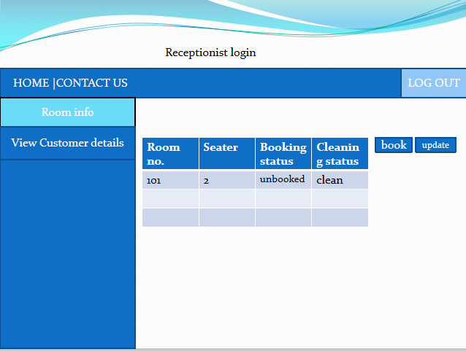

Service Layer:

When we click on Room Info button the service layer function gets called named as roomInfoRec() -

* Input argument- nothing
* Return status as 1 and it will contain a list of Room-it will redirect to Room Information page
* Return status 0 on no record- we will show “No record found”

Dao Layer:

findRoomListForRec() function gets called -

* Input argument- nothing
* Return- ArrayList of Room object

*View Customer details:*

Presentation Layer:

Here it will consist of personal information of Guests who are presently staying in the hotel.

* A table of Customers will come up containing several columns and every record will have buttons like Update (for further update in future).
* Table will contain columns named as-
  + CustomerId
  + GovtId
  + Name
  + Gender
  + Phone_no
  + City_address
  + Pincode
  + RoomNo
  + CheckinDate
  + CheckinTime
  + CheckoutDate
  + CheckoutTime

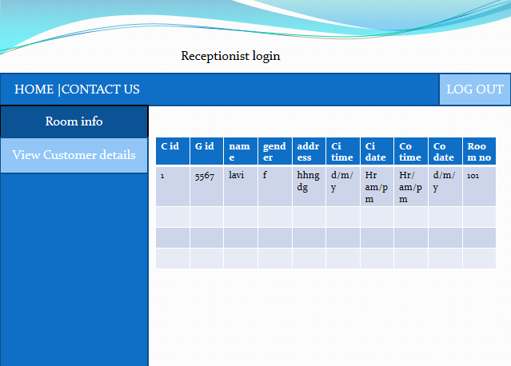

Service Layer:

When we click on *View Customer details* button the service layer function gets called named as viewCustomerDetails() -

* Input argument- nothing
* Return status as 1 and it will contain a list of Customers-it will redirect to Customer’s Information page
* Return status 0 on no record- we will show “No record found”

Dao Layer:

findCustomersList() function gets called -

* Input argument- nothing
* Return- ArrayList of Customer object